Experiment / Case Study No.: 6
EXPERIMENT
1. Experiment Title:
To perform various String operations using JavaScript. a) To perform basics of String. b) Work with strings: substring(), indexOf(), split(), replace().
2. Software/Tools Required:
VS Code (text editor), HTML, CSS, JavaScript.
3. Experiment Program Code:
String Lab — Basics of String Operations (index.html + style.css + script.js) –
index.html:
<!DOCTYPE html>
<html lang="en">
<head>
<meta charset="UTF-8">
<meta name="viewport" content="width=device-width, initial-scale=1.0">
<title>String Lab — JavaScript String Operations</title>
<link rel="preconnect" href="https://fonts.googleapis.com">
<link href="https://fonts.googleapis.com/css2?family=Fraunces:ital,opsz,wght@0,9..144,500;0,9..144,600;0,9..144,700;1,9..144,500&family=IBM+Plex+Mono:wght@400;500;600;700&family=Work+Sans:wght@400;500;600&display=swap" rel="stylesheet">
<link rel="stylesheet" href="style.css">
</head>
<body>

<div class="noise"></div>

<header class="hero">
<p class="eyebrow">JavaScript &nbsp;/&nbsp; Practical No. 6a</p>
<h1 class="title">String<span class="cursor">_</span>Lab</h1>
<p class="subtitle">Type anything below. Watch every string method react to it, live.</p>
</header>

<!-- SIGNATURE: live playground -->
<section class="playground">
<div class="playground-head">
<span class="dot red"></span><span class="dot yellow"></span><span class="dot green"></span>
<span class="playground-label">playground.js</span>
</div>

<div class="input-row">
<span class="prompt">const str =</span>
<input id="strInput" type="text" value="Hello JavaScript World" spellcheck="false">
</div>

<div id="resultsGrid" class="results-grid"></div>
</section>

<footer class="footer">
<p>Built with plain JavaScript — no libraries, just strings.</p>
</footer>

<script src="script.js"></script>
</body>
</html>

style.css:
:root {
--bg: #f7f2e7;
--panel: #fffdf8;
--panel-alt: #efe6d2;
--border: #ddd0af;
--text: #2b2417;
--muted: #8a7c5f;
--ink: #3d4b8c;
--gold: #b8791f;
--rust: #9c4a26;

--font-display: 'Fraunces', serif;
--font-mono: 'IBM Plex Mono', monospace;
--font-sans: 'Work Sans', sans-serif;
}

* { box-sizing: border-box; }

html { scroll-behavior: smooth; }

body {
margin: 0;
background: var(--bg);
color: var(--text);
font-family: var(--font-sans);
line-height: 1.5;
position: relative;
overflow-x: hidden;
}

/* faint paper grain */
.noise {
position: fixed;
inset: 0;
pointer-events: none;
opacity: 0.05;
z-index: 0;
mix-blend-mode: multiply;
background-image: url("data:image/svg+xml,%3Csvg xmlns='http://www.w3.org/2000/svg' width='120' height='120'%3E%3Cfilter id='n'%3E%3CfeTurbulence type='fractalNoise' baseFrequency='0.9' numOctaves='2' stitchTiles='stitch'/%3E%3C/filter%3E%3Crect width='100%25' height='100%25' filter='url(%23n)'/%3E%3C/svg%3E");
}

/* ---------- HERO ---------- */
.hero {
max-width: 720px;
margin: 0 auto;
padding: 32px 24px 18px;
text-align: center;
position: relative;
z-index: 1;
}

.eyebrow {
font-family: var(--font-mono);
font-size: 11px;
letter-spacing: 0.12em;
text-transform: uppercase;
color: var(--ink);
margin: 0 0 8px;
}

.title {
font-family: var(--font-display);
font-weight: 600;
font-style: normal;
font-size: clamp(32px, 6vw, 48px);
margin: 0;
letter-spacing: -0.01em;
color: var(--text);
}

.title::after {
content: "";
}

.cursor {
color: var(--rust);
font-family: var(--font-display);
font-style: italic;
font-weight: 500;
animation: blink 1.1s step-end infinite;
}

@keyframes blink {
50% { opacity: 0; }
}

.subtitle {
font-size: 13.5px;
color: var(--muted);
margin: 8px auto 0;
max-width: 420px;
font-family: var(--font-sans);
}

/* ---------- PLAYGROUND ---------- */
.playground {
max-width: 720px;
margin: 0 auto 28px;
padding: 0 24px;
position: relative;
z-index: 1;
}

.playground-head {
background: var(--panel-alt);
border: 1px solid var(--border);
border-bottom: none;
border-radius: 10px 10px 0 0;
padding: 8px 14px;
display: flex;
align-items: center;
gap: 8px;
}

.dot {
width: 8px;
height: 8px;
border-radius: 50%;
display: inline-block;
opacity: 0.85;
}
.dot.red { background: #c96a4e; }
.dot.yellow { background: var(--gold); }
.dot.green { background: #5c8a5a; }

.playground-label {
margin-left: 10px;
font-family: var(--font-mono);
font-size: 12.5px;
color: var(--muted);
}

.input-row {
background: var(--panel);
border: 1px solid var(--border);
border-top: none;
padding: 12px 16px;
display: flex;
align-items: center;
gap: 10px;
}

.prompt {
font-family: var(--font-mono);
color: var(--rust);
font-size: 13px;
white-space: nowrap;
}

#strInput {
flex: 1;
background: transparent;
border: none;
outline: none;
font-family: var(--font-mono);
font-size: 13.5px;
color: var(--ink);
padding: 3px 0;
border-bottom: 1px dashed var(--border);
}

#strInput:focus {
border-bottom-color: var(--ink);
}

.results-grid {
background: var(--panel);
border: 1px solid var(--border);
border-top: none;
border-radius: 0 0 10px 10px;
padding: 12px;
display: grid;
grid-template-columns: repeat(auto-fit, minmax(180px, 1fr));
gap: 8px;
box-shadow: 0 12px 28px -22px rgba(43, 36, 23, 0.35);
}

.result-card {
background: var(--panel-alt);
border: 1px solid var(--border);
border-radius: 8px;
padding: 9px 11px;
transition: border-color 0.2s ease, transform 0.2s ease, box-shadow 0.2s ease;
}

.result-card:hover {
border-color: var(--ink);
transform: translateY(-1px);
box-shadow: 0 8px 18px -14px rgba(61, 75, 140, 0.4);
}

.result-method {
font-family: var(--font-mono);
font-size: 10.5px;
color: var(--gold);
display: block;
margin-bottom: 3px;
}

.result-value {
font-family: var(--font-mono);
font-size: 12px;
color: var(--text);
word-break: break-all;
}

.result-hint {
display: block;
font-size: 9.5px;
color: var(--muted);
margin-top: 3px;
font-family: var(--font-sans);
}

/* ---------- FOOTER ---------- */
.footer {
text-align: center;
padding: 10px 24px 24px;
color: var(--muted);
font-size: 10.5px;
font-family: var(--font-mono);
position: relative;
z-index: 1;
}

@media (max-width: 520px) {
.input-row { flex-direction: column; align-items: flex-start; }
#strInput { width: 100%; }
}

script.js:
// ---------------------------------------------
// 6a. Basics of String + 6b. substring(), indexOf(), split(), replace()
// ---------------------------------------------

const strInput = document.getElementById("strInput");
const resultsGrid = document.getElementById("resultsGrid");

function buildResults(str) {
// Guard against an empty string so methods don't throw / look broken
const safe = str.length ? str : " ";

return [
{
method: "str.length",
value: str.length,
hint: "Number of characters in the string"
},
{
method: "str.toUpperCase()",
value: str.toUpperCase(),
hint: "Basics — every letter capitalised"
},
{
method: "str.toLowerCase()",
value: str.toLowerCase(),
hint: "Basics — every letter lowercased"
},
{
method: "str.trim()",
value: `"${str.trim()}"`,
hint: "Basics — removes leading/trailing spaces"
},
{
method: "str.charAt(0)",
value: safe.charAt(0),
hint: "Basics — character at a given index"
},
{
method: "str.substring(0, 5)",
value: safe.substring(0, 5),
hint: "Characters from index 0 up to (not including) 5"
},
{
method: 'str.indexOf("a")',
value: str.indexOf("a"),
hint: "Position of the first match, or -1 if not found"
},
{
method: 'str.split(" ")',
value: JSON.stringify(str.split(" ")),
hint: "Breaks the string into an array of words"
},
{
method: 'str.replace("World", "Java")',
value: str.replace("World", "Java"),
hint: "Swaps the first match for new text"
}
];
}

function render() {
const str = strInput.value;
const results = buildResults(str);

resultsGrid.innerHTML = results
.map(
(r) => `
<div class="result-card">
<span class="result-method">${r.method}</span>
<span class="result-value">${escapeHtml(String(r.value))}</span>
<span class="result-hint">${r.hint}</span>
</div>`
)
.join("");
}

function escapeHtml(text) {
return text
.replace(/&/g, "&amp;")
.replace(/</g, "&lt;")
.replace(/>/g, "&gt;");
}

strInput.addEventListener("input", render);

// ---------------------------------------------
// Initial render on page load
// ---------------------------------------------
render();

4. Output:
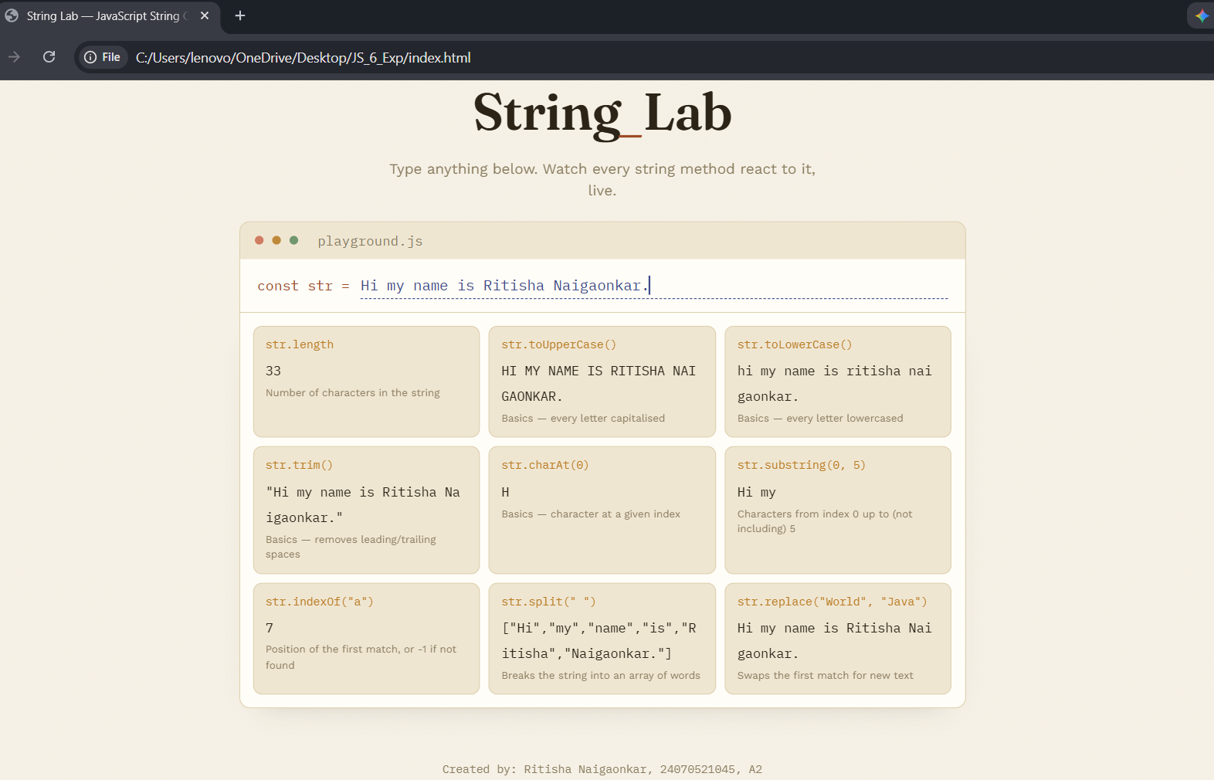
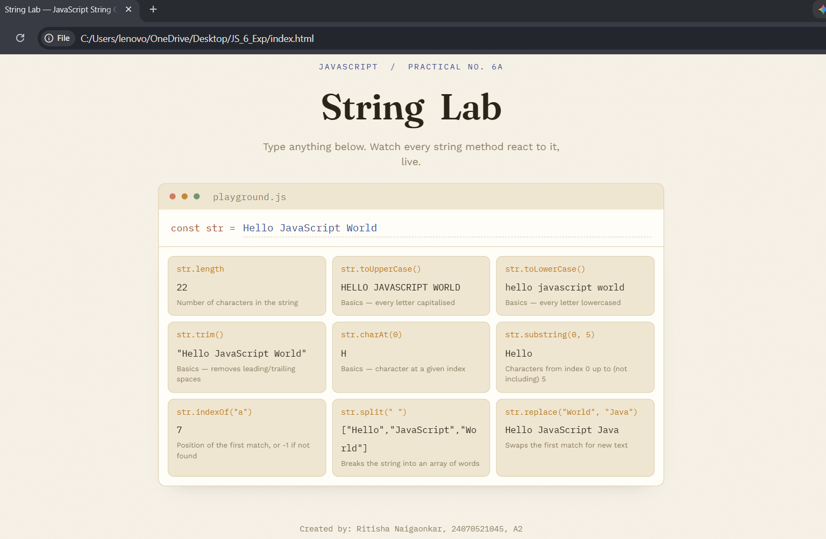
CASE STUDY
5. Case Study Title:
1. Write a program to reverse a string. 2. Write a program to count the number of vowels in a paragraph.
6. Case Study Program Code:
String Lab — Reverse String & Vowel Counter (index.html + style.css + script.js) –
index.html:
<!DOCTYPE html>
<html lang="en">
<head>
<meta charset="UTF-8">
<meta name="viewport" content="width=device-width, initial-scale=1.0">
<title>String Lab — JavaScript String Operations</title>
<link rel="preconnect" href="https://fonts.googleapis.com">
<link href="https://fonts.googleapis.com/css2?family=Fraunces:ital,opsz,wght@0,9..144,500;0,9..144,600;0,9..144,700;1,9..144,500&family=IBM+Plex+Mono:wght@400;500;600;700&family=Work+Sans:wght@400;500;600&display=swap" rel="stylesheet">
<link rel="stylesheet" href="style.css">
</head>
<body>

<div class="noise"></div>

<header class="hero">
<h1 class="title">String<span class="cursor">_</span>Lab</h1>
<p class="subtitle">Type anything below. Watch every string method react to it, live.</p>
</header>

<!-- SIGNATURE: live playground -->
<section class="playground">
<div class="playground-head">
<span class="dot red"></span><span class="dot yellow"></span><span class="dot green"></span>
<span class="playground-label">playground.js</span>
</div>

<div class="input-row">
<span class="prompt">const str =</span>
<input id="strInput" type="text" value="Hello JavaScript World" spellcheck="false">
</div>

<div id="resultsGrid" class="results-grid"></div>
</section>

<!-- Case study section -->
<section class="case-study">
<p class="eyebrow">Case Study</p>
<div class="case-grid">
<article class="case-card">
<span class="case-index">01</span>
<h3>Reverse a string</h3>
<p class="case-desc">Flip the input above — letter by letter, back to front.</p>
<div class="case-output">
<span class="case-output-label">output</span>
<span id="reverseOutput" class="case-output-value">—</span>
</div>
</article>

<article class="case-card">
<span class="case-index">02</span>
<h3>Count the vowels</h3>
<p class="case-desc">Every a, e, i, o, u in the input, uppercase or lower.</p>
<div class="case-output">
<span class="case-output-label">output</span>
<span id="vowelOutput" class="case-output-value">—</span>
</div>
</article>
</div>

<div class="paragraph-block">
<label for="paraInput" class="paragraph-label">Try the vowel counter on a full paragraph</label>
<textarea id="paraInput" rows="4" spellcheck="false">The quick brown fox jumps over the lazy dog. JavaScript makes strings easy to explore, one character at a time.</textarea>
<div class="paragraph-result">
Vowels found: <span id="paraVowelCount">0</span>
</div>
</div>
</section>

<footer class="footer">
<p>Created by: Ritisha Naigaonkar, 24070521045, A2</p>
</footer>

<script src="script.js"></script>
</body>
</html>

style.css:
:root {
--bg: #f7f2e7;
--panel: #fffdf8;
--panel-alt: #efe6d2;
--border: #ddd0af;
--text: #2b2417;
--muted: #8a7c5f;
--ink: #3d4b8c;
--gold: #b8791f;
--rust: #9c4a26;

--font-display: 'Fraunces', serif;
--font-mono: 'IBM Plex Mono', monospace;
--font-sans: 'Work Sans', sans-serif;
}

* { box-sizing: border-box; }

html { scroll-behavior: smooth; }

body {
margin: 0;
background: var(--bg);
color: var(--text);
font-family: var(--font-sans);
line-height: 1.5;
position: relative;
overflow-x: hidden;
}

.noise {
position: fixed;
inset: 0;
pointer-events: none;
opacity: 0.05;
z-index: 0;
mix-blend-mode: multiply;
background-image: url("data:image/svg+xml,%3Csvg xmlns='http://www.w3.org/2000/svg' width='120' height='120'%3E%3Cfilter id='n'%3E%3CfeTurbulence type='fractalNoise' baseFrequency='0.9' numOctaves='2' stitchTiles='stitch'/%3E%3C/filter%3E%3Crect width='100%25' height='100%25' filter='url(%23n)'/%3E%3C/svg%3E");
}

.hero {
max-width: 720px;
margin: 0 auto;
padding: 32px 24px 18px;
text-align: center;
position: relative;
z-index: 1;
}

.eyebrow {
font-family: var(--font-mono);
font-size: 11px;
letter-spacing: 0.12em;
text-transform: uppercase;
color: var(--ink);
margin: 0 0 8px;
}

.title {
font-family: var(--font-display);
font-weight: 600;
font-style: normal;
font-size: clamp(32px, 6vw, 48px);
margin: 0;
letter-spacing: -0.01em;
color: var(--text);
}

.title::after {
content: "";
}

.cursor {
color: var(--rust);
font-family: var(--font-display);
font-style: italic;
font-weight: 500;
animation: blink 1.1s step-end infinite;
}

@keyframes blink {
50% { opacity: 0; }
}

.subtitle {
font-size: 13.5px;
color: var(--muted);
margin: 8px auto 0;
max-width: 420px;
font-family: var(--font-sans);
}

.playground {
max-width: 720px;
margin: 0 auto 28px;
padding: 0 24px;
position: relative;
z-index: 1;
}

.playground-head {
background: var(--panel-alt);
border: 1px solid var(--border);
border-bottom: none;
border-radius: 10px 10px 0 0;
padding: 8px 14px;
display: flex;
align-items: center;
gap: 8px;
}

.dot {
width: 8px;
height: 8px;
border-radius: 50%;
display: inline-block;
opacity: 0.85;
}
.dot.red { background: #c96a4e; }
.dot.yellow { background: var(--gold); }
.dot.green { background: #5c8a5a; }

.playground-label {
margin-left: 10px;
font-family: var(--font-mono);
font-size: 12.5px;
color: var(--muted);
}

.input-row {
background: var(--panel);
border: 1px solid var(--border);
border-top: none;
padding: 12px 16px;
display: flex;
align-items: center;
gap: 10px;
}

.prompt {
font-family: var(--font-mono);
color: var(--rust);
font-size: 13px;
white-space: nowrap;
}

#strInput {
flex: 1;
background: transparent;
border: none;
outline: none;
font-family: var(--font-mono);
font-size: 13.5px;
color: var(--ink);
padding: 3px 0;
border-bottom: 1px dashed var(--border);
}

#strInput:focus {
border-bottom-color: var(--ink);
}

.results-grid {
background: var(--panel);
border: 1px solid var(--border);
border-top: none;
border-radius: 0 0 10px 10px;
padding: 12px;
display: grid;
grid-template-columns: repeat(auto-fit, minmax(180px, 1fr));
gap: 8px;
box-shadow: 0 12px 28px -22px rgba(43, 36, 23, 0.35);
}

.result-card {
background: var(--panel-alt);
border: 1px solid var(--border);
border-radius: 8px;
padding: 9px 11px;
transition: border-color 0.2s ease, transform 0.2s ease, box-shadow 0.2s ease;
}

.result-card:hover {
border-color: var(--ink);
transform: translateY(-1px);
box-shadow: 0 8px 18px -14px rgba(61, 75, 140, 0.4);
}

.result-method {
font-family: var(--font-mono);
font-size: 10.5px;
color: var(--gold);
display: block;
margin-bottom: 3px;
}

.result-value {
font-family: var(--font-mono);
font-size: 12px;
color: var(--text);
word-break: break-all;
}

.result-hint {
display: block;
font-size: 9.5px;
color: var(--muted);
margin-top: 3px;
font-family: var(--font-sans);
}

.case-study {
max-width: 720px;
margin: 0 auto;
padding: 0 24px 20px;
position: relative;
z-index: 1;
}

.case-study .eyebrow { text-align: left; margin-bottom: 4px; }

.section-title {
font-family: var(--font-display);
font-size: 21px;
font-weight: 600;
margin: 0 0 12px;
}

.case-grid {
display: grid;
grid-template-columns: repeat(auto-fit, minmax(240px, 1fr));
gap: 10px;
margin-bottom: 14px;
}

.case-card {
background: var(--panel);
border: 1px solid var(--border);
border-radius: 10px;
padding: 14px 16px;
position: relative;
}

.case-index {
font-family: var(--font-mono);
font-size: 10px;
color: var(--muted);
letter-spacing: 0.1em;
}

.case-card h3 {
font-family: var(--font-display);
font-weight: 600;
font-size: 15.5px;
margin: 5px 0 4px;
}

.case-desc {
color: var(--muted);
font-size: 11.5px;
margin: 0 0 10px;
}

.case-output {
background: var(--panel-alt);
border: 1px solid var(--border);
border-radius: 6px;
padding: 7px 10px;
display: flex;
align-items: center;
gap: 8px;
}

.case-output-label {
font-family: var(--font-mono);
font-size: 9px;
color: var(--muted);
text-transform: uppercase;
}

.case-output-value {
font-family: var(--font-mono);
color: var(--ink);
font-size: 13px;
word-break: break-all;
}

.paragraph-block {
background: var(--panel);
border: 1px solid var(--border);
border-radius: 10px;
padding: 14px 16px;
}

.paragraph-label {
display: block;
font-size: 11px;
color: var(--muted);
margin-bottom: 8px;
}

#paraInput {
width: 100%;
background: var(--panel-alt);
border: 1px solid var(--border);
border-radius: 8px;
color: var(--text);
font-family: var(--font-mono);
font-size: 12px;
padding: 10px;
resize: vertical;
outline: none;
min-height: 60px;
}

#paraInput:focus {
border-color: var(--ink);
}

.paragraph-result {
margin-top: 8px;
font-family: var(--font-mono);
color: var(--rust);
font-size: 12.5px;
}

#paraVowelCount {
color: var(--gold);
font-weight: 700;
}

.footer {
text-align: center;
padding: 10px 24px 24px;
color: var(--muted);
font-size: 10.5px;
font-family: var(--font-mono);
position: relative;
z-index: 1;
}

@media (max-width: 520px) {
.input-row { flex-direction: column; align-items: flex-start; }
#strInput { width: 100%; }
}

script.js:
// ---------------------------------------------
// 6a. Basics of String + 6b. substring(), indexOf(), split(), replace()
// ---------------------------------------------

const strInput = document.getElementById("strInput");
const resultsGrid = document.getElementById("resultsGrid");

function buildResults(str) {

const safe = str.length ? str : " ";

return [
{
method: "str.length",
value: str.length,
hint: "Number of characters in the string"
},
{
method: "str.toUpperCase()",
value: str.toUpperCase(),
hint: "Basics — every letter capitalised"
},
{
method: "str.toLowerCase()",
value: str.toLowerCase(),
hint: "Basics — every letter lowercased"
},
{
method: "str.trim()",
value: `"${str.trim()}"`,
hint: "Basics — removes leading/trailing spaces"
},
{
method: "str.charAt(0)",
value: safe.charAt(0),
hint: "Basics — character at a given index"
},
{
method: "str.substring(0, 5)",
value: safe.substring(0, 5),
hint: "Characters from index 0 up to (not including) 5"
},
{
method: 'str.indexOf("a")',
value: str.indexOf("a"),
hint: "Position of the first match, or -1 if not found"
},
{
method: 'str.split(" ")',
value: JSON.stringify(str.split(" ")),
hint: "Breaks the string into an array of words"
},
{
method: 'str.replace("World", "Java")',
value: str.replace("World", "Java"),
hint: "Swaps the first match for new text"
}
];
}

function render() {
const str = strInput.value;
const results = buildResults(str);

resultsGrid.innerHTML = results
.map(
(r) => `
<div class="result-card">
<span class="result-method">${r.method}</span>
<span class="result-value">${escapeHtml(String(r.value))}</span>
<span class="result-hint">${r.hint}</span>
</div>`
)
.join("");

updateCaseStudy(str);
}

function escapeHtml(text) {
return text
.replace(/&/g, "&amp;")
.replace(/</g, "&lt;")
.replace(/>/g, "&gt;");
}

strInput.addEventListener("input", render);

// ---------------------------------------------
// Case Study 1: Reverse a string
// ---------------------------------------------
function reverseString(str) {
return str.split("").reverse().join("");
}

// ---------------------------------------------
// Case Study 2: Count the number of vowels
// ---------------------------------------------
function countVowels(str) {
const matches = str.match(/[aeiou]/gi);
return matches ? matches.length : 0;
}

const reverseOutput = document.getElementById("reverseOutput");
const vowelOutput = document.getElementById("vowelOutput");

function updateCaseStudy(str) {
reverseOutput.textContent = str.length ? reverseString(str) : "—";
vowelOutput.textContent = str.length ? countVowels(str) : "0";
}

// Paragraph vowel counter
const paraInput = document.getElementById("paraInput");
const paraVowelCount = document.getElementById("paraVowelCount");

function updateParagraphCount() {
paraVowelCount.textContent = countVowels(paraInput.value);
}

paraInput.addEventListener("input", updateParagraphCount);

// ---------------------------------------------
// Initial render on page load
// ---------------------------------------------
render();
updateParagraphCount();

7. Output:
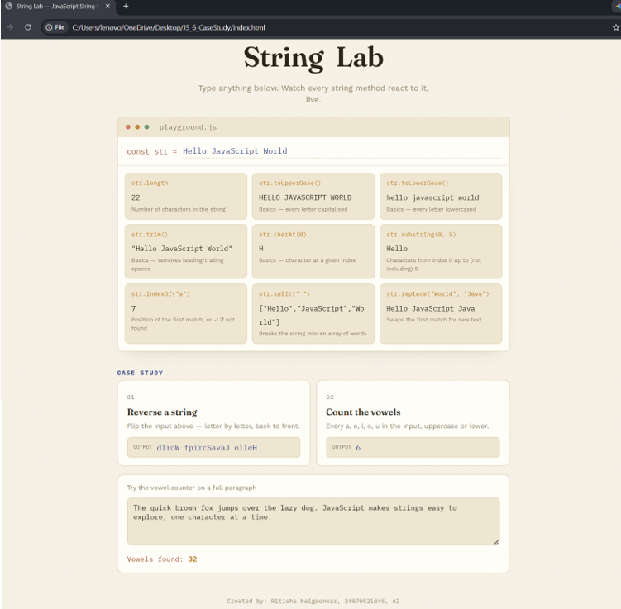
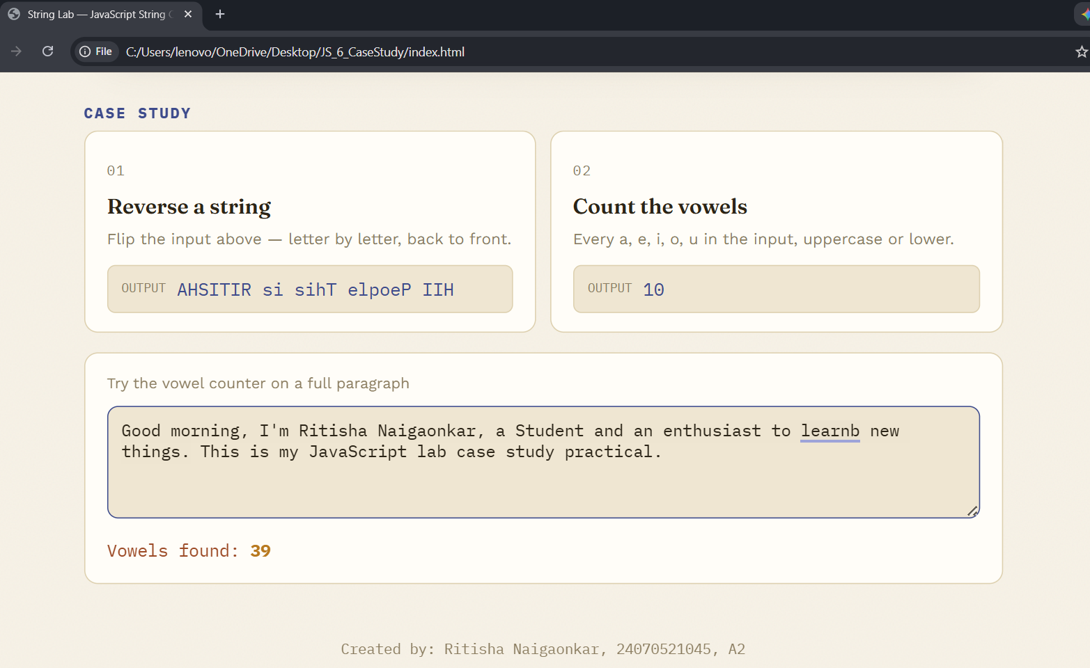
8. Result/Conclusion:
Thus various String operations in JavaScript were studied and implemented, including basic string properties and methods (length, toUpperCase(), toLowerCase(), trim(), charAt()) as well as substring(), indexOf(), split() and replace(). The case study programs to reverse a string and count the number of vowels in a paragraph were also implemented, and the desired output was verified.
Ritisha Naigaonkar, 24070521045, V-A(A2)

